ENVI1400 : INTRODUCTION TO METEOROLOGY & WEATHER FORECASTING
Assessed Worksheet

This work sheet is part of the assessed course-work for this module; it makes up 15% of your total marks. You should complete the work on this sheet, and submit it to the undergraduate office along with a completed cover sheet. The deadline for this worksheet is 4pm, Friday November 18. Late work will be penalised 5% for each day it is late (including weekends!).

1) Figure 1 shows a sea-level pressure and 1000-500mb thickness forecast chart from the MetOffice.
- Estimate the geostrophic wind speed (in knots) at the locations marked, and whether the true wind speed is likely to be high or lower than the geostrophic value: (6 marks)

A:

B:

C:

- Draw an arrow on the chart to indicate the direction of the surface wind at each location. (2 marks)

- If you travelled north along the Greenwich Meridian (0° longitude), at approximately what latitude would you first expect precipitation to fall as snow instead of rain? (1 mark)

- The chart shows that a warm front is expected to move across London during the morning, give a brief, general description of what changes you would expect in the weather as the front approaches and passes. Include details of cloud cover, precipitation, and temperature changes. (5 marks)

2) If the depth of the layer between 1000mb and 500mb is increasing with time, is the surface temperature likely to be increasing or decreasing? (1 mark)

3) Figures 2a and 2b show air temperature plotted on tephigrams.
- For each case state whether the near-surface layer is stable or unstable. (2 marks)

Figure 2a:

Figure 2b:

- For each case state if the radiosonde passed through cloud, and if so, the pressure levels between which cloud was present (3 marks)
Figure 2a:
Figure 2b:

- For the unstable case, draw an arrow indicating the adiabatic ascent of surface air to its level of neutral stability, and indicate the maximum level to the rising air might overshoot, and whether cloud would form and if so at what pressure level. (5 marks)

- For each case state the pressure level (to the nearest 10mb) at which the tropopause is located. (2 marks)

Figure 2a tropopause at :

Figure 2b tropopause at :

4) Standing (in Leeds) facing into the wind, you look up and observe that the high-level clouds are coming from your right.
- In which direction, relative to you, is the lower pressure (left, right, in front, or behind) (1 mark)

- Would you expect the weather to improve, get worse, or remain about the same over the next day or two? (1 mark)

- If you made the same observations while in New Zealand, in which direction would the low pressure be, and would you expect the weather to improve or get worse? (2 marks)

5) Why can’t you estimate a geostrophic wind speed close to the equator? (2 marks)

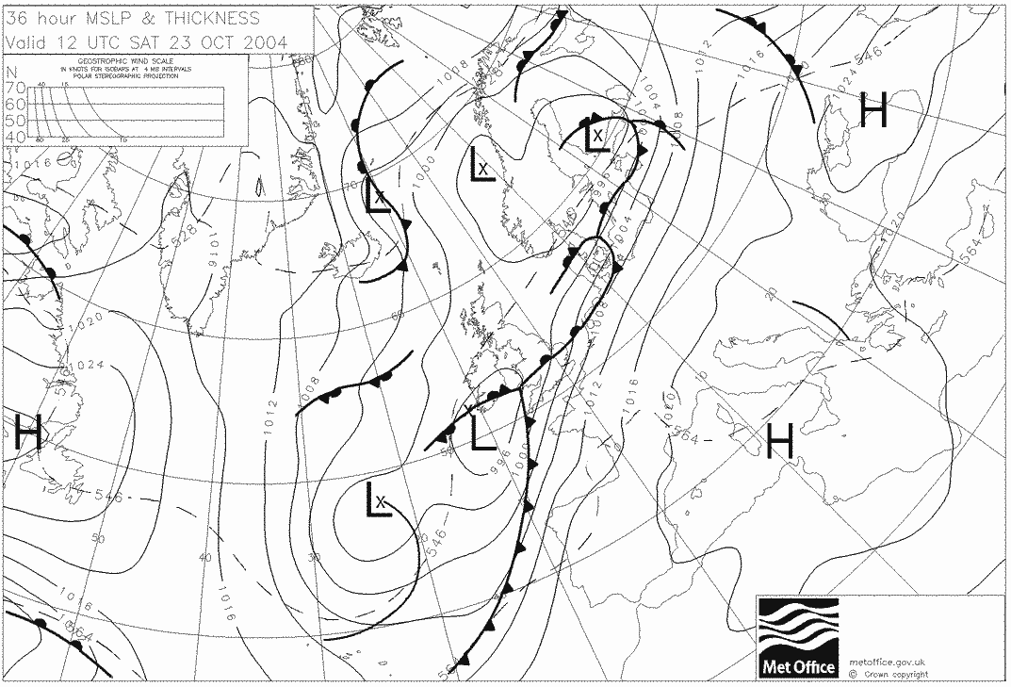
10
15
25
40
80
A
B
C
Figure 1
Figure 2a. Figure 2b.
