Unit 5 Practical Output
Student ID : <insert-id>

You should complete this assignment independently using the spaces provided below to type your answers or to paste relevant outputs from your GIS or statistical analysis.
You should then save this document using the filename DVA_Unit5_[StudentID] replacing [student ID] with your own student ID number.

For this assignment you do not need to include the usual School of Geography assessment coversheet as a separate form will be used for marking and feedback.
This assessment is designed to give you an opportunity to apply the spatial and quantitative analysis skills that you have developed throughout this module. You do not need to learn any new GIS or statistical analysis techniques to be able to complete these tasks. You should complete these activities using the datasets and guidance provided within the practical handouts. You should also re-read the module handbook (available on the VLE) which provides further information on assessment including policies related to word limits, late submission and mitigating circumstances.
Please upload this document to the relevant submission box in the VLE no later than Monday 11 November 2019 at 2pm
Please note that your first submission is final – you cannot overwrite with later versions so please ensure you attach the correct completed document.
Marking Scheme  (Each Output will be marked out of 100) |  | Unit Mark:
100 | Excellent attempt – no obvious flaws | Brief justification for mark:
75 | Good attempt – some minor flaws
50 | Satisfactory attempt – some major flaws
25 | Poor attempt - serious flaws
0 | No attempt

Task Brief
This is a short, assessed task. It does not assume knowledge or skills above what you have learnt in the lecture and this session. Ideally, the task should be completed within the practical session -- the aim is not to burden you with additional work.
The task is designed to:
- check that you can produce outputs in Tableau
- assess your understanding of data types and their visual encoding
Once you’ve completed the task, save using the filename “DVA_Unit5_<StudentID>.docx” replacing [student ID] with your own student ID number.
Upload the completed document to the VLE, via the Assessment page.
I have included an example of a graphic I created on the same dataset, but deliberately not using (and not possible with) Tableau. Consult the lecture slides for a reminder of data types and visual variables (or channels).
Step 1 : Export
Select a single graphic from the set that you have just created in the practical. Edit the title in Tableau with: "<some sensible title>". Remember you need to double click and update the contents of the Edit Title window. Export the graphic as a .png file by navigating to Worksheet, Export, Image. Paste the graphic into The Graphic box below.
Step 2 : Describe
Describe the encoding used in the graphic by completing the table under The Encoding box below. Consult the example graphic and lecture slides for guidance here.
Step 3 : Upload
Remove the comments from the assessment template as per the instructions at the top of the page below, save using the filename “DVA_Unit5_<StudentID>.docx” and upload to the VLE.

Please use this document to complete and upload the assessed task.

DELETE all of the blue boxes that contain instructions – they are just for guidance.

Use ‘Styles’ in Word to remove this formatting – revert paragraphs to ‘Normal’ style to remove boxes!

THE GRAPHIC : Data Graphic to describe

Paste a copy of the selected graphic in the table below.
Graphic | 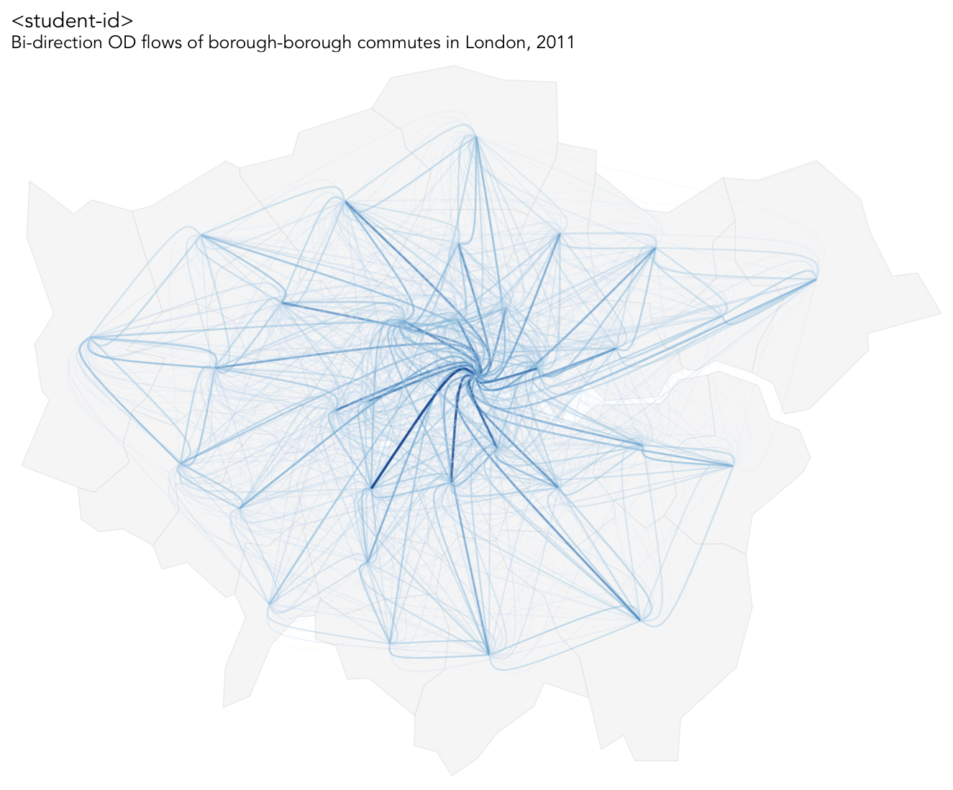Paste graphic here!

THE ENCODING : Data Dimensions, Visual Characteristics

Identify all data dimensions (or channels) that you have represented in the data graphic, and describe their encoding by listing the nature of variation (level of measurement) and the visual characteristic(s) you have used to depict them.

Data Dimension | Nature of Variation | Visual Characteristic / Variable / Channel
OD flow count … | Ratio | Size (line thickness)
OD flow count … | Ratio | Colour lightness
London borough origin … | Ordinal | Curvature
London borough destination … | Ordinal | Curvature
London borough centroid… | Ratio | Location (x,y)
London borough area (background map)… | Ratio | Size
London borough shape (background map)… | Nominal | Shape

