Palaeoclimate Modelling Practical

EBM & Holocene Climate Variability

Aim of the Practical

I am afraid that you will not have a chance to run a GCM. Although computer time is much cheaper, it would still take too long. Instead, you are going to examine the output from some simulations, which have already been completed, using an EBM and a GCM. There are about 20 GCM simulations, representing simulations at 1000 year intervals from the Last Glacial Maximum (21,000 years ago) to the present. They are not with the complete GCM, but using an atmospheric GCM coupled to a simple slab ocean model. CO₂ and CH₄ are based on the observed ice core record. Land ice sheets are specified according to Peltier (1994, Science). Sea level changes are also included, and this accounts for a few of the odd “bulls eye” changes that you will occasionally see on some of the plots. It is best to ignore them. NOTE: the model uses an astronomical time scale.

The climate model we are using is the Hadley Centre GCM. It has been extensively used in future climate change research and was widely used in last report of the Intergovernmental Panel on Climate Change (IPCC). However, the model was developed in the context of modern climate and there has been very little testing of the model in different climate regimes.

The aim of this practical is to evaluate whether a set of simulations represents a reasonable depiction of climate change especially for the present-day and the mid-Holocene climatic optimum (6 ka). As such, you will be helping to evaluate how much confidence we should have in this world-leading model.

You are given a number of examples of geological datasets to consider. They include observed changes in a variety of different indicators of past climate. They have mainly been drawn from papers in the special issue of Quaternary Science Reviews (2000, p. 1-480) and from the book Global Climates since the Last Glacial Maximum (1993, ed. Wright, Kutzbach, Webb, Ruddiman, Street-Perrott, and Bartlein, Univ. of Minnesota Press) and also from CAPE Project Members 2001 (QSR, 20, 1275-1287) &

Structure

The practical is divided into two parts.

Part 1: Energy Balance Modelling:
For this section in groups of two or three you will need to run the CD-ROM provided. In the control panel click on the CD Drive and the double click on Runwin. The CD will then load. Once loaded click on Energy Balance Model in the main menu.

Things to do:

- Read and make notes on the introduction page to EBMs
- Now press the fwd arrow and bring up a model prediction for the modern climate with standard settings. Comment on the simulated temperature field – is it what you might expect.

- Now begin to manipulate the settings of the model. Settings that can be changed include:

- Atmospheric CO₂
- Solar Constant
- Poleward Heat Transport
- Strength of Ice-Albedo Feedback

Describe how the results differ from the initial setting of the model by analyzing the anomaly field. Make sure you fully understand why the change in the model setting produces the change in model prediction.

- Briefly comment on the strengths and weaknesses of such a simple EBM in determining the potential causes(s) of past climate change.

Part 2. Introduction to the web pages
Some of the output from the climate simulations using the GCM can be found in:

http://www.bridge.bris.ac.uk/resources/simulations.htm

Then enter the Guest site

1) Read the introduction carefully. To test the workings, access the model simulation of precipitation for the modern. The broad patterns are very comparable to the observed distribution, but the details are different (some of the differences may be due to poor observations of precipitation rather than a poor model).

2) Now lets test the model for the palaeo. The experiments you need are: xamka through to xamkv

i) Holocene Climate Change – Lake level fluctuations

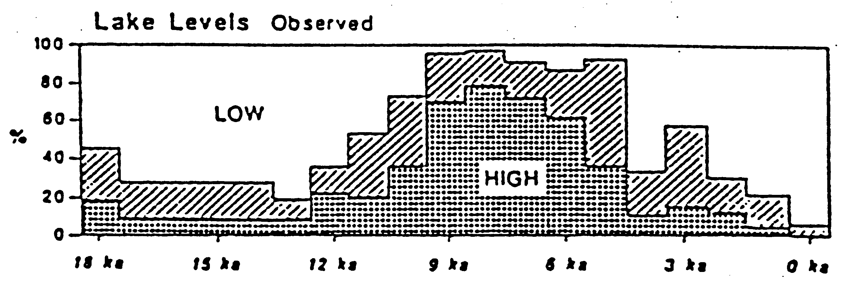
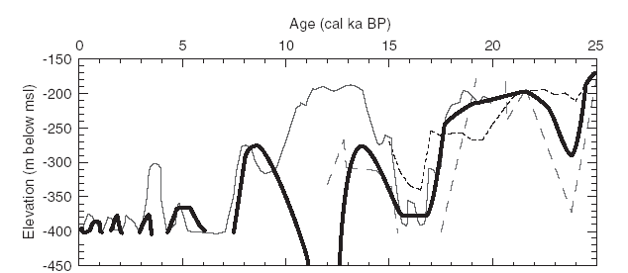
Fig. 1: Observed lake level data for every 1000 years between the LGM and present day. The dates are in ¹⁴C timescale, so 6 ¹⁴C ka BP is reasonably similar to astronomical 6 ka) but 18 ¹⁴C kyr BP corresponds to about 21 ka BP astronomical. The lake levels are averaged between 8.9 N and 26.6 N.

Fig. 2: Observed lake level data (Lake Lisan/Dead Sea) for every 1000 years between 25Ka and present day. The dates are in ¹⁴C timescale, so 6 ¹⁴C ka BP is reasonably similar to astronomical 6 ka) but 18 ¹⁴C kyr BP corresponds to about 21 ka BP astronomical.

Test these reconstructed variations in lake levels against model predictions. Select the climatological variables carefully is it variations in precipitation that you need to examine or something else?

Are the LGM and mid-Holocene (~6ka) simulations convincing compared to the lake level data and what about for other time periods?

ii) Pollen and Biome Records (BIOME 6000)

Below are a series of maps, which summarise observational records and pollen data regionally for 0 and 6 ka, and map it into what biome types exist(ed) in different areas at these times. Use the biome plots for these time periods and compare them to what the model predicted biomes are. When you have identified the differences try and determine which model climate variable such as cloud cover, precipitation, or surface temperature may be causing the data/model inconsistency.

EUROPE:
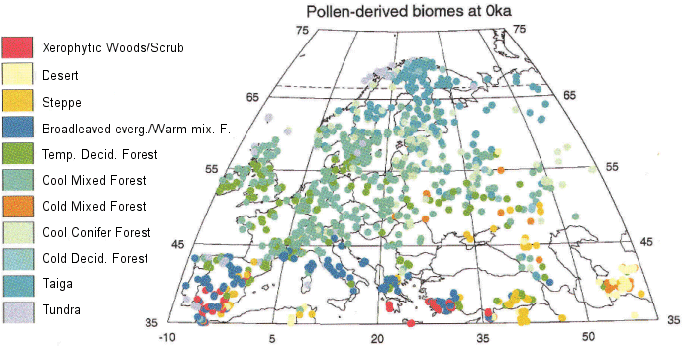

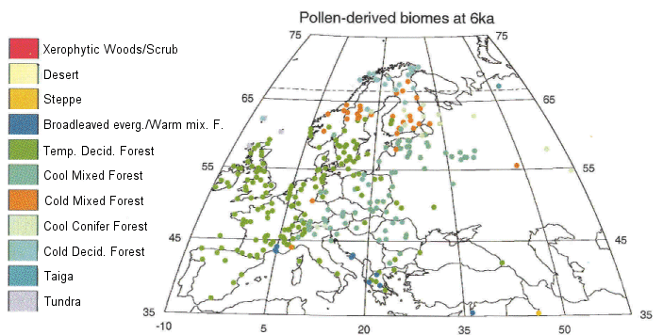

Fig. 3: Biome 6000 maps over the European sector for 0 and 6 ka BP. Derived from modern observations and the biomitization of pollen records.

AFRICA:
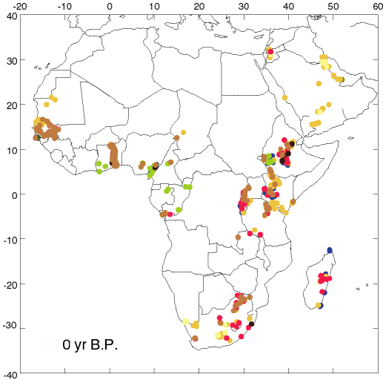

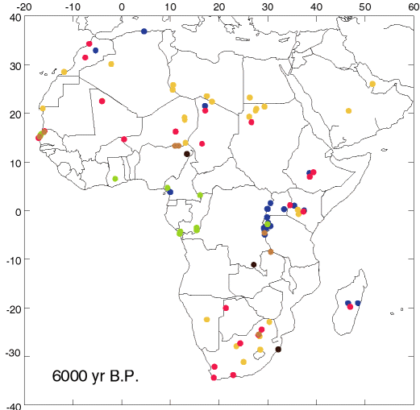

Fig. 4: BIOME 6000 plots for 0 ka and 6 ka over the African region

III. Arctic Palaeo temperature data (CAPE Project)
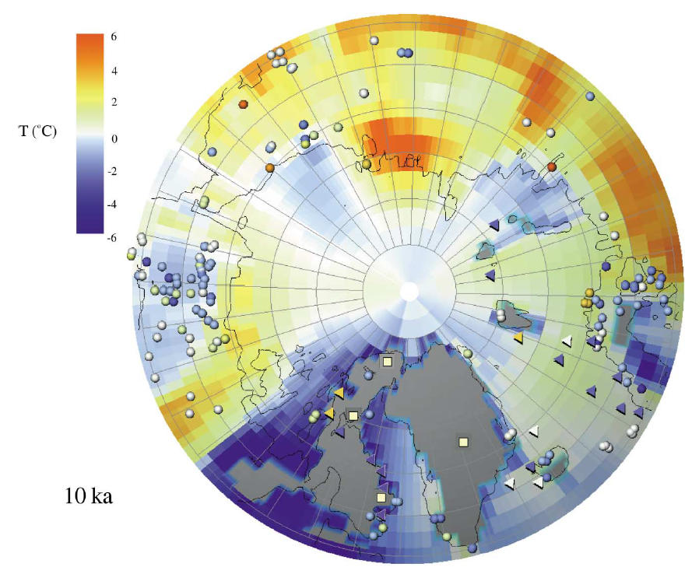
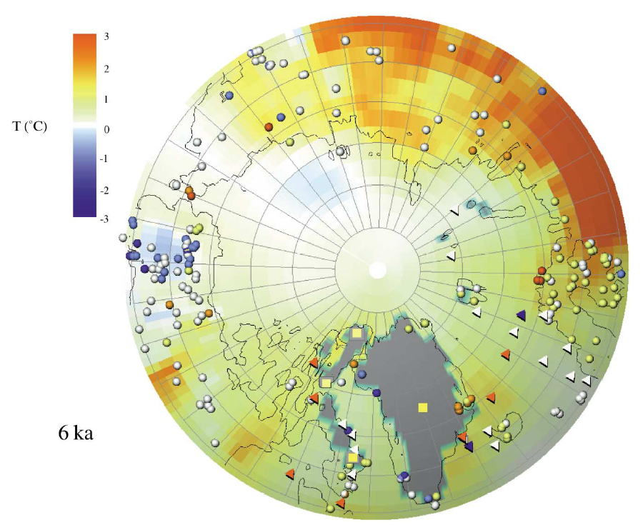
Figure 5: Arctic palaeo temperature data for 10 and 6 Ka derived from the CAPE Project. Also shown are the results for surface temperature for the same time intervals from the GENSIS GCM. Both maps show the departures of mean summer (JJA) temperatures from Present day.

Now compare these data to our model results for the Arctic. How well does the model reproduce the seasonal change in temperature for 10 and 6 Ka and how similar are our model predictions to those shown on the maps derived using the GENESIS model?

